**Step 1** Create new table “employee sales” load with “employee” table selecting these columns: Attrition, Department, JobSatisfaction, MonthlyIncome.

CREATE TABLE employee_sales

(

Attrition string,

Department string,

JobSatisfaction int,

MonthlyIncome float

);

INSERT OVERWRITE TABLE employee_sales

SELECT Attrition, Department, JobSatisfaction, MonthlyIncome

FROM employee;

SELECT * FROM employee_sales LIMIT 10;

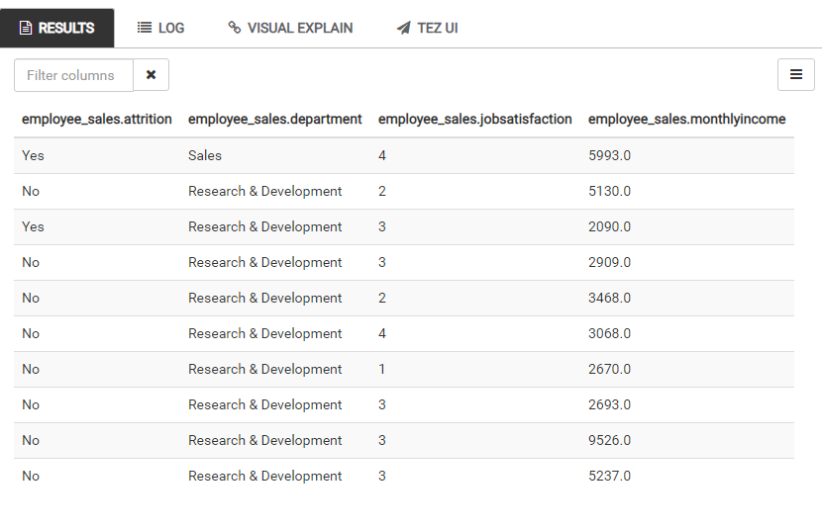

**Step 2** Round the data in MonthlyIncome to nearest $1000

INSERT OVERWRITE TABLE employee_sales

SELECT Attrition, Department, JobSatisfaction, ROUND(MonthlyIncome,-3) AS MonthlyIncome

FROM employee_sales

;

SELECT * FROM employee_sales LIMIT 10;

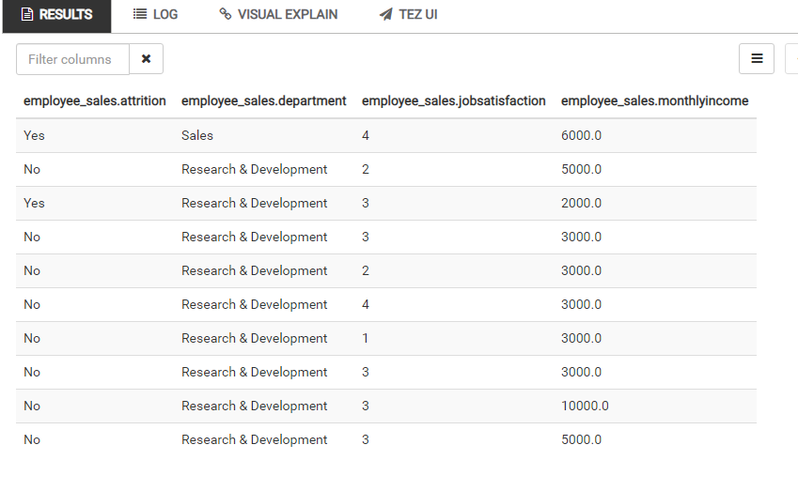

**Step 3** Filter only Sales Department items

INSERT OVERWRITE TABLE employee_sales

SELECT *

FROM employee_sales

WHERE Department LIKE ‘%Sales%’;

SELECT * FROM employee_sales LIMIT 10;

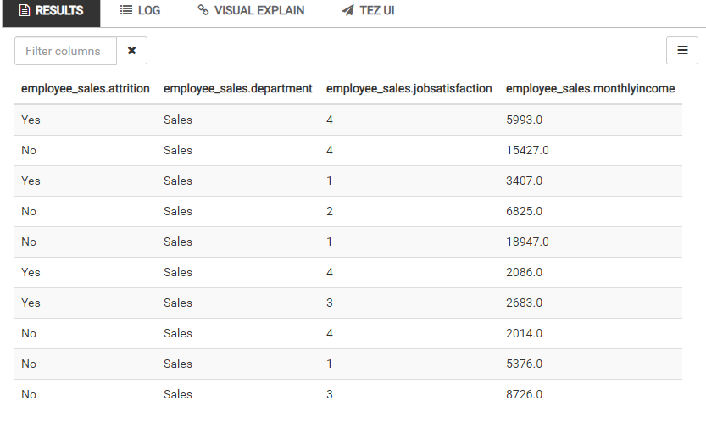

**Step 4** Order Data by Job Satisfaction

INSERT OVERWRITE TABLE employee_sales

SELECT *

FROM employee_sales

ORDER BY JobSatisfaction DESC

;

SELECT * FROM employee_sales LIMIT 10;

